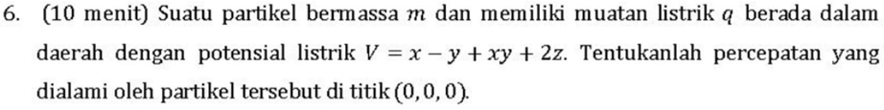

m = massa
q = muatan Listrik
V= potensial Listrik
“a” di titik (0,0,0) =?
Rumus:
$$E=-∇V$$
$$∑F=ma(newton)$$
$$F=qE$$
$$E=-∇V$$
$$E=-\frac{∂V}{∂x}\hat{i}-\frac{∂V}{∂y}\hat{j}-\frac{∂V}{∂z}k ̂$$
$$V=(x-y+xy+2z)$$
$$E=-\left(1+y\right)\hat{i}-\left(-1+x\right)\hat{j}-2k ̂$$
Karna mencari di titik (x, y, z) = (0, 0, 0)
$$E=-1\hat{i}+1\hat{j}-2k ̂$$

Masukan di rumus F=qE
$$F=q(-1\hat{i}+1\hat{j}-2k ̂)$$
Dan karena F = ma, jadi gabung
$$ma=q(-1\hat{i}+1\hat{j}-2k ̂)$$
Dan karna kita mencari a nya, maka
$$a=\frac{q\left(-1\hat{i}+1\hat{j}-2\hat{k}\right)}{m}$$

Kita cari energi total (U)?
q = muatan Listrik
R=jari2

Rumus:
$$U=∫u dτ$$
$$τ=volum$$
$$u=rapat energi$$
Mencari rapat energi:
$$u=\frac{1}{2}ε_{0}E^{2}$$
$$E=medan listrik$$
$$ε_{0}=permitivitas hampa$$
Mencari nilai E (medan listrik):
Pakai hukum gauss:
$$∇.E=\frac{q}{ε_{0}}$$
$$∮E dA=\frac{q}{ε_{0}}$$
$$E.A=\frac{q}{ε_{0}}$$
Mencari A:
$$luas bola=4πr^{2}$$
$$E.4πr^{2}=\frac{q}{ε_{0}}$$
$$E=\frac{q}{{4πr^{2}ε}_{0}}$$
Masukan ke rumus u:
$$u=\frac{1}{2}ε_{0}({\frac{q}{{4πr^{2}ε}_{0}})}^{2}$$
Masukan ke U:
$$U=∫u dτ$$
Mencari $dτ:$

Jadikan $dτ menjadi dr:$
$$volume bola (τ)=\frac{4}{3}πr^{3}$$
$$dτ=\frac{4}{3}π3r^{2}dr$$
$$dτ=4πr^{2}dr$$
Dimasukan ke rumus U:
$$U=\int_{R}^{∞}{u 4πr^{2}dr}$$

Hukum gauss: medan Listrik (E) dalam bola itu 0
$$jadi, r<R maka E=0$$
$$sedangkan, r≥R maka berlaku ∇.E=\frac{q}{ε_{0}}$$
$$U=\int_{R}^{∞}{\frac{1}{2}ε_{0}({\frac{q}{{4πr^{2}ε}_{0}})}^{2} 4πr^{2}dr}$$
$$U=\int_{R}^{∞}{\frac{q^{2}}{8πr^{2}ε_{0}}dr}$$
$$U=\frac{q^{2}}{8πRε_{0}}$$

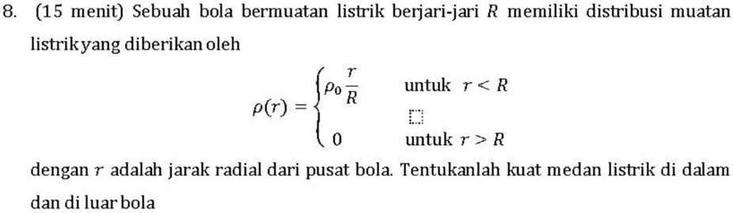

Mencari E (medan listrik)?
Hukum gauss:
$$∇.E=\frac{q}{ε_{0}}$$
$$∮E dA=\frac{q}{ε_{0}}$$
$$E.A=\frac{q}{ε_{0}}$$
$$E=\frac{q}{A ε_{0}}$$
Mencari A:
$$A=4πr^{2}$$
Masukan A ke rumus E:
$$E=\frac{q}{4πr^{2} ε_{0}}$$
Mencari q (muatan listrik):
$$q=ρV$$
$$q=∫ρ dV$$

Pertama cari ‘r’ di dalam bola:
$$q=\int_{0}^{r}{ρ dV}$$
$$q=\int_{0}^{r}{\frac{ρ_{0}r}{R} dV}$$
Rubah dV menjadi dr:
$$V=\frac{4}{3}πr^{3}$$
$$\frac{dV}{dr}=4πr^{2}$$
$$dV=4πr^{2}dr$$
Masukan dV ke rumus q:
$$q=\int_{0}^{r}{\frac{ρ_{0}r}{R} 4πr^{2}dr}$$
$$q=\frac{πρr^{4}}{R}$$
Masukan q ke E:
$$E=\frac{\frac{πρr^{4}}{R}}{4πr^{2} ε_{0}}$$
$$E_{dalam}=\frac{ρr^{2}}{4Rε_{0}}$$
Mencari E di luar:
$$q=\int_{0}^{R}{ρ dV}$$
$$q=\int_{0}^{R}{\frac{ρ_{0}r}{R} dV}$$
Rubah dV menjadi dr:
$$V=\frac{4}{3}πr^{3}$$
$$\frac{dV}{dr}=4πr^{2}$$
$$dV=4πr^{2}dr$$
Masukan dV ke rumus q:
$$q=\int_{0}^{R}{\frac{ρ_{0}r}{R} 4πr^{2}dr}$$
$$q=ρ_{0}πR^{3}$$
Masukan q ke E:
$$E=\frac{ρ_{0}πR^{3}}{4πr^{2} ε_{0}}$$
$$E_{luar}=\frac{ρR^{3}}{4ε_{0}r^{2}}$$

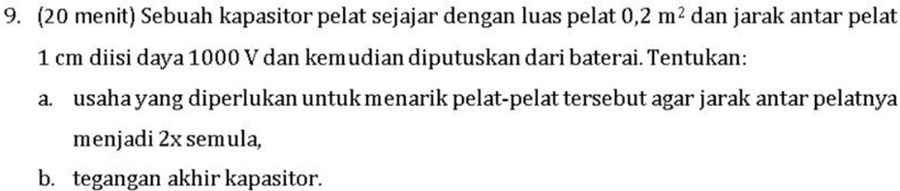

Diketahui:
A = 0,2 m2
d = 1 cm = 0,01m
V = 1000V
q (muatan) nya tetap karena diputus baterai.

- Rumus kapasitansi awal:
$$C_{0}=\frac{ε_{0}A}{d_{0}}$$
$$rumus q:$$
$$Q=CV$$

Mencari usaha (W):
$$W=ΔU=U^{'}-U_{0}$$
Mencari energi awal ($U_{0}$)
$$U_{0}=1/2{ (C}_{0}V_{0}^{2})$$
Asal rumus (intermezzo):
$$dW=\int_{0}^{Q}{V dq}$$
$$V=\frac{q}{C}$$
$$\int_{0}^{W}{dW}=\int_{0}^{Q}{\frac{q}{C} dq}$$
$$W=\frac{1}{2}{(Q}^{2}/C)$$
$${U_{0}=W}_{0}=\frac{1}{2}C_{0}V_{0}^{2}$$
$$mencari kapasitansi akhir:$$
$$C^{'}=\frac{ε_{0}A}{{2d}_{0}}=\frac{1}{2}C_{0}$$
$$mencari energi akhir:$$
$$U^{'}=\frac{1}{2}CV^{2}=1/2{ (Q}^{2}/C')$$
$$U^{'}=1/2(C_{0}^{2}V_{0}^{2}/(\frac{1}{2C_{0}})$$
$$U^{'}=C_{0}V_{0}^{2}$$
$$mencari usaha:$$
$${W=U}^{'}-U_{0}=C_{0}V_{0}^{2}-\frac{1}{2}C_{0}V_{0}^{2}=\frac{1}{2}C_{0}V_{0}^{2}$$
$$\frac{1}{2}\frac{ε_{0}A}{d_{0}}V_{0}^{2}=8,85x{10}^{-5}J$$
- Tegangan akhir (V’)
$$Q=C^{'}V^{'}=C_{0}V_{0}$$
$$V^{'}=Q/C^{'}$$
$$V^{'}=\frac{C_{0}V_{0}}{\frac{1}{2}C_{0}}=2V_{0}=2000V$$

